444 Comments in 218 Exact Seconds : Data Reveals
How Coordinated Facebook Network Praising Border Force Chief after a Report

DHAKA — A coordinated online campaign utilizing dedicated accounts, narratives, sponsored advertisements, and same ‘copy-past text’ comments artificially flooded on Facebook to shield Border Guard Bangladesh Director General Major General Mohammad Ashrafuzzaman Siddiqui and project a ‘humanitarian image’ of the border force following a critical investigative report, an Activate Rights analysis shows.
On October 1, Netra News published an investigative report examining the role of Major General Mohammad Ashrafuzzaman Siddiqui during the July 2024 mass uprising. Right after that, BGB rejected the findings in a statement posted on its verified Facebook page. In the days that followed, a number of Facebook pages and accounts campaign praising the border force and its chief, some of it seen promoted through paid advertisements. Several of these posts described the report as part of a foreign-funded effort to damage the institution's reputation.
Our examination of 3,717 public comments across the posts uncovered systematic patterns of Coordinated Inauthentic Behavior. More than 57 percent of all analyzed comments were exact copy-paste duplicates. Server timestamp logs further exposed 444 comments hit the servers at the exact same second across 218 time clusters, as well as rapid-fire account execution where single profiles posted up to 14 identical comments within an eight-second span.
What Was the Investigation?
Investigation by Netra News and Bangladesh Protest Archiveindicate that BGB personnel, operating independently or jointly with police forces, were involved in at least 86 fatal shooting incidents during July Uprising including major casualties in Dhaka's Rampura-Banasree corridor, Narsingdi, and Sylhet after receiving orders permitting maximum force and lethal weaponry. While field-level officers such as Lieutenant Colonel Redwanul Islam and Major Rifat bin Alam Moon are currently facing prosecution at a special tribunal for alleged crimes against humanity, legal observers and victims' families continue to raise questions regarding command responsibility and institutional accountability concerning senior leadership, including BGB Director General Major General Mohammad Ashrafuzzaman Siddiqui.
After the report was published on Netra News's Facebook page and YouTube channel, its facebook comment sections drew a number of critical comments. Most of these expressed support for BGB and its Director General and criticised Netra News. A follow-up search of Facebook using several related keywords revealed what appeared to be a coordinated promotional campaign.

A Coordinated Campaign
To examine the scale and nature of this response, we searched Facebook for posts containing the keywords "BGB" and “BGB Director General”, in both Bangla and English, published between 12:01 a.m. on October 2 and 11:59 p.m. on October 5. We collected every post that praised BGB or its Director General without reference to any specific event, or that criticised Netra News over the report. Over the four days, we identified 24 such posts from different facebook pages and profiles.
Posts published by some facebook pages including bgbnews, Shimanter News24, Military Power, and BRAVE-GUARD circulated statements rejecting the news report as "motivated, baseless, and fabricated." These posts explicitly accused "vested quarters" backed by foreign funding and external influence of attempting to destroy public trust in BGB and weaken national border security.

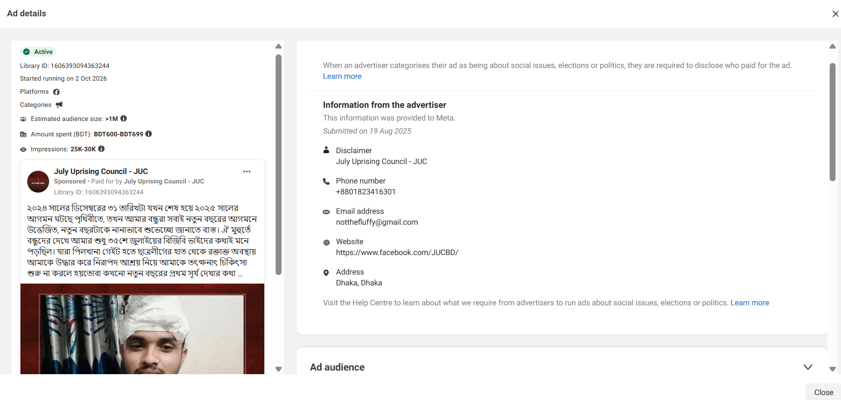
Caption : A Facebook page named July Uprising Council was observed running paid promotional campaigns praising the Bangladesh border guard force, Following an investigative report.
Among these posts, Two posts recorded the highest numbers of shares and comments. Preliminary observation of their comment sections suggested coordinated operation. Consequently, We evaluated 3,717 public comments gathered between October 2 and October 5 via open source data tools, establishing a comprehensive dataset to judge the timing, coordination, and authenticity of the network campaign.

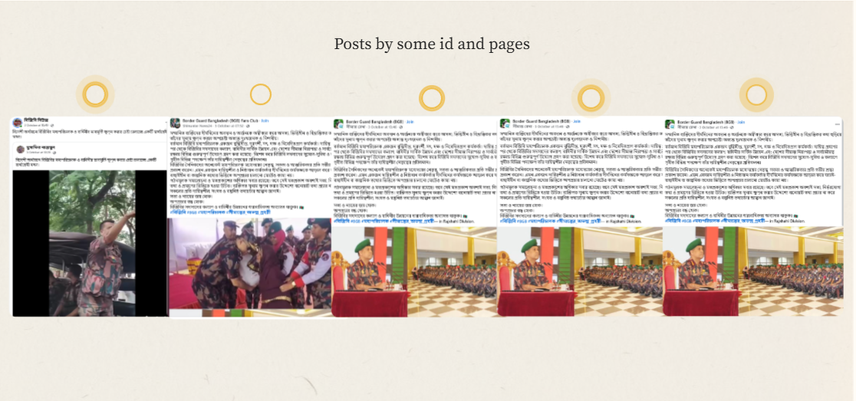
bgbnews, Shimanter News24, Military Power, and BRAVE-GUARD - এদের পোস্টগুলো স্ক্রিনশর্ট আকারে আসবে। একটি রেখা বাম থেকে ডানে যাবে আর নিচে পাঁচটি পোস্ট স্ক্রিনশর্ট আসবে। https://view.genially.com/6accae1b2deb6bd5815bd1fe
The initial post was the official response issued on BGB’s verified Facebook page, which dismissed the Netra News report as "misleading, baseless, and motivated." In a detailed ten-point rebuttal, the border force accused the news outlet of context distortion, selective video editing, and misinterpreting command responsibility without presenting direct written orders, ballistics, or forensic proof. This post gained substantial traction, gathering 17,000 reactions alongside 3,500 comments, with we extracting and analyzing the initial 1,945 comments.
The second one was a post by the community page July Revolutionary Alliance-JRA, showcasing BGB's humanitarian efforts throughout the July Uprising, including the story of a JRA leader describing BGB personnel treating him during July with 10 head stitches, as well as testimonials depicting the border force chief as a restrained leader who refused to use lethal force against student demonstrators during the July uprising.
Notably, although the JRA post concentrated no direct reference to the BGB Director General, its comment section was overwhelmed by off-topic remarks lavishing praise on Major General Siddiqui. The JRA post gained 5,600 reactions, 5,900 shares, and of which all the 1,772 comments were extracted for analysis.
The comments exhibited clear content patterns characterized by mass text duplication and the strategic heroification of BGB Director General Major General Siddiqui, Moreover a Identical long-form text These findings point to an orchestrated campaign that employed bulk duplicate messaging and cross-page account coordination to fabricate the illusion of organic public backing and shield senior military leadership from criticism.

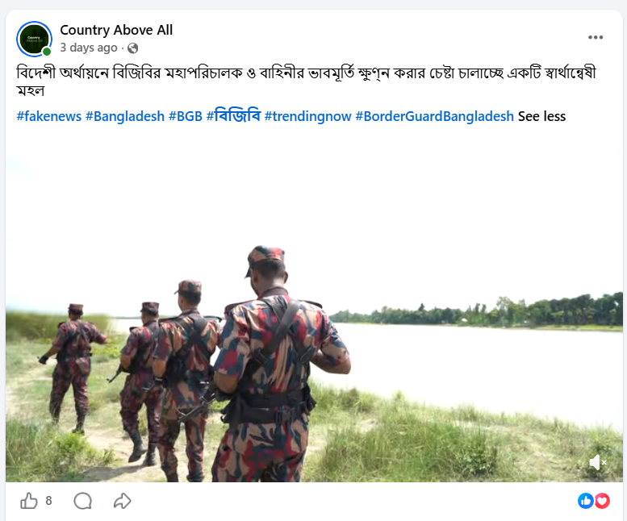
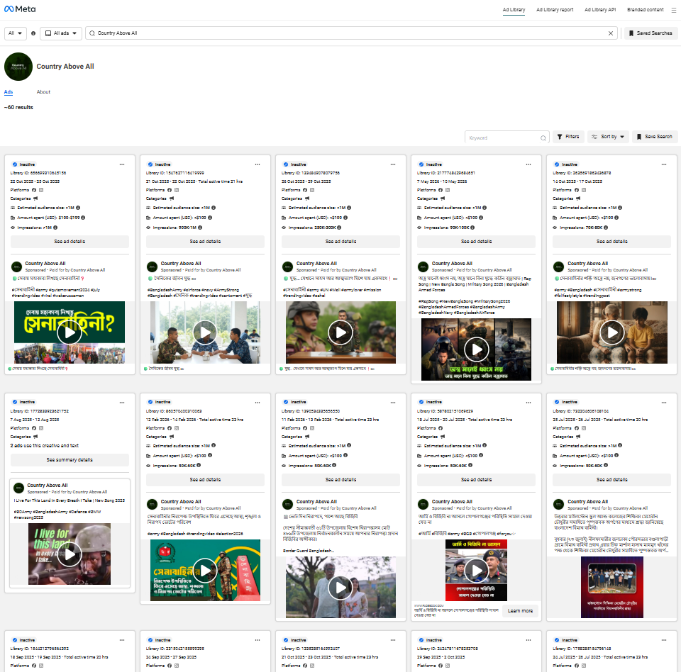
Screenshot Collage 001 : A page name ‘Country above all’ defending BGB had history of positive paid campaign about Military and state forces before

MASSIVE DUPLICATION
More than half of all analyzed comments were exact copy-paste duplicates looking like generated from a central bank of prepared text templates. Out of 3,717 total comments from both posts, 2,137 remarks—representing 57.49 percent of the dataset—were identical copies of existing text rather than organic public responses.
The concentration of duplicate content was highest on the post published by the July Revolutionary Alliance, 1,228 out of 1,772 comments, or 69.3 percent, were identical copy-paste text. On the official BGB Facebook page, duplicate comments accounted for 45.8 percent of all activity, totaling 890 out of 1,945 remarks.

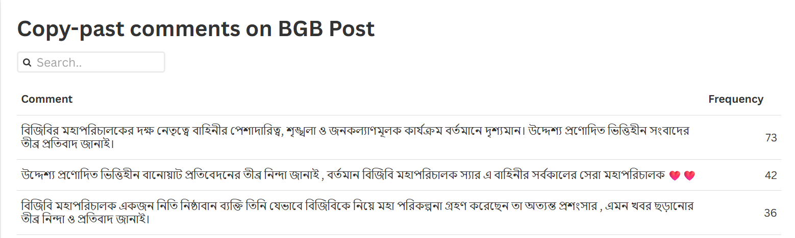
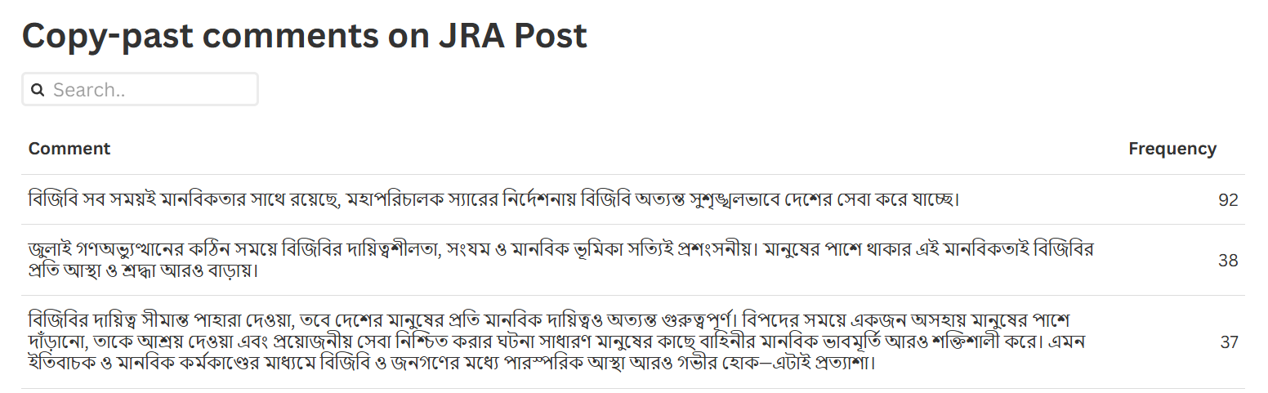
Analysis of the response showed that the three most frequently duplicated comments appeared 73, 42, and 36 times on the BGB post. Meanwhile, on the JRA post, the most recurring copy-pasted comments were posted 92, 38, and 37 times. Comprehensive data on these repetitions can be accessed via Flourish and Flourish.

[ছয়টা শীর্ষ কমেন্ট টেক্সট যা]

TIMING
A select group of accounts repeatedly flooded the comment section with identical remarks. Such as, user accounts operating under the names "Tompa Saha" and "Ful koli" made 38 comments each on a single post, while "Milon Khan" posted 34 times, "Janin Ali Khan" submitted 28 remarks, "Paharer Soundarzya" (Beauty of the Hills) posted 26 times, and "Samol Saya" made 21 comments.
In one instance on October 3, the account "Ful koli" published 14 identical copy-paste comments within just eight seconds between 11:05:18 am and 11:05:26 am, averaging a comment every half-second, before publishing another 13 identical comments within a seven-second window shortly after.
Similarly, the profile "Tompa Saha" published 15 identical comments in a ten-second span between 11:14:36 am and 11:14:46 am, while "Milon Khan" did six comments in four seconds.

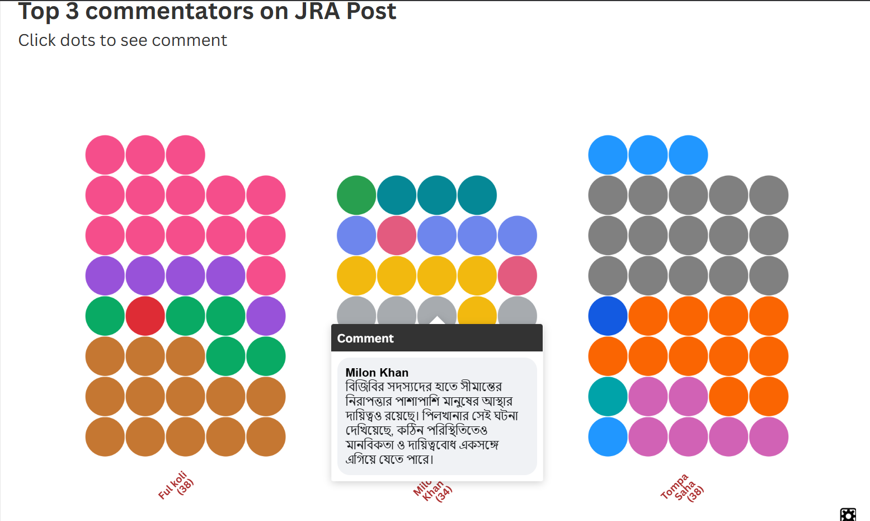
See here- https://public.flourish.studio/visualisation/30542237/

<div class="flourish-embed flourish-survey" data-src="visualisation/30542237"><script src="https://public.flourish.studio/resources/embed.js"></script><noscript><img src="https://public.flourish.studio/visualisation/30542237/thumbnail" width="100%" alt="survey visualization" /></noscript></div>

Data analysis also identified exact-second concurrency, where multiple profiles posted comments at the exact same second. Across 218 unique timestamps, 444 comments hit Facebook at the same second. This included one instance on October 2 at 9:28:03 pm where four distinct accounts published separate praise comments at the exact same second, as well as six instances where three comments registered simultaneously.
By platform distribution, July Revolutionary Alliance (JRA) page recorded the highest concentration of concurrent activity with 370 comments across 175 timestamp clusters, while the official BGB post recorded 74 comments across 36 timestamp clusters.
Such as on October 2 at 9:28:03 pm, four distinct user accounts published separate defensive comments at the exact same second on the official BGB Facebook post. four distinct user accounts published separate defensive comments at the exact same second on the official BGB Facebook post. The simultaneous entries included remarks from profiles named Md Nahid, Obuj Balok, Obujh Balok (written in Bengali), and Rana Islam, each offering praise for Major General Siddiqui.

[Timing er bar chart hobe]
A similar duplication error occurred later that morning on the July Revolutionary Alliance post on October 3, 2026, at 11:07:26 am. Server records showed three comments registering simultaneously, including a remark by MD Lutfor Rahman and two identical entries published at the exact same second by the account Ful koli describing soldiers assisting an injured protester.

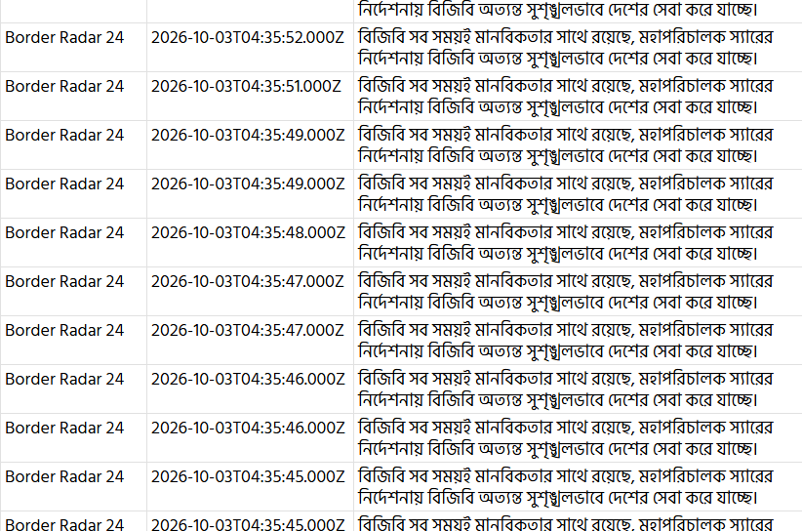
Caption: Same comments appeared simultaneously across multiple accounts, including 'Border Radar 24', 'Border Pulse', and 'Border Watch 360'.

The campaign operated in distinct, timed waves rather than a steady stream of organic interaction. The first wave targeted the official BGB Facebook page on October 2, where 1,072 comments were submitted within four hours, reaching a peak of 393 comments in a single hour at 9:00 pm.
Once activity on the official page subsided, a second wave hit community pages on October 3. Between 10:00 am and 2:00 pm, accounts poured 1,300 comments into JRA posts, reaching a peak rate of 483 comments per hour at 12:00 pm. Following these concentrated bursts, comment volumes abruptly dropped to near zero.

FOUR CORE DEFENSIVE NARRATIVES
The network propagated four primary messaging themes designed to neutralize criticism and highlight institutional achievements.
The most common narrative directly attacked the news report, with 1,312 comments branding the Netra News investigation as motivated, unfounded, or fake news. A second narrative focused on building the personal image of the border Director General, with 426 comments praising Major General Siddiqui and 149 remarks explicitly calling him the greatest director general in BGB history.
A third narrative invoked the July 2024 uprising, using 202 comments to highlight the border force's humanitarian role during political unrest. Finally, 201 comments deployed pre-written stories, including a 31-comment duplicate account of soldiers treating an injured protester and an 18-comment corporate-style summary of recent structural upgrades and equipment purchases under the current director general.
The most widely circulated comment template across the dataset was a single paragraph praising the border force's leadership, reading: "BGB is always with humanity; under the direction of the Director General Sir, BGB is serving the country in an extremely disciplined manner." This exact text was seen in comment section 92 times on the July Revolutionary Alliance post alone. Remarkably, the post was never about BGB DG, but the comment section was flooded with comments praising the DG—733 times, 41.4 percent of total comments.
A detailed account describing BGB personnel treating an injured protester with 10 head stitches at Pilkhana gate before safely placing him on a rickshaw was published word-for-word across 31 separate comments in JRA post. Similarly, a lengthy official summary detailing Major General Siddiqui’s administrative achievements—including Myanmar border management, the creation of 2,258 new force positions, and the acquisition of surveillance drones—was posted word-for-word 18 times.

Fake profile and pages spotted
An analysis of the 18 accounts generating the highest comments on the July Revolutionary Alliance (JRA) post demonstrates clear patterns of artificial creation and low follower counts. Among these, 13 profiles were created in 2026 including six registered on a single day on August 20, namely Ful koli, Montu molla, For you & Blue sky (in Bangla), Hasna Hena, and Mizanur Rahman. Two accounts were created on August 19, two on September 9, and the remaining five were set up in late 2025, three in November and two in December.
These 18 profiles exhibited uniform activity, none demonstrated independent social media engagement, and all exclusively reshared content from a single Facebook page named "Nirbheek Uttorer Veer", which solely distributes Border Guard Bangladesh (BGB)-related material.
In place of genuine individual interaction, scores of repetitive comments came from accounts classified under commercial business categories despite showing no commercial operations and having minimal followings such as Tasmin Yesmin, listed as a 'women's clothing store' with 30 followers, which submitted 15 comments praising military leadership; Janin Ali Khan, a 'tire repair shop' page with 12 followers that posted 28 comments; and Tompa Saha, a 'health and beauty' page with 15 followers that posted 38 comments.

CROSS-POST NETWORK COORDINATION
Centralized coordination was further confirmed by network overlap across separate Facebook pages. Seventeen master text templates were used interchangeably across both official BGB posts and third-party community posts.
The most repeated template—a paragraph praising the director general's farsighted leadership—appeared 38 times across different pages. Additionally, data cross-referencing identified 296 identical Facebook profiles that posted comments on both the official BGB post and secondary pages within hours of each other, confirming a single network operating across multiple digital fronts.
A page named July Uprising Council-JUC ran sponsored advertisements circulating humanitarian narratives about the border force, and Zero line also posted the same story of JRA.
while another page, Country Above All, launched a targeted counter-narrative accusing a "vested quarter backed by foreign funding" of attempting to tarnish the reputation of the BGB and its leadership.
Investigation into Country Above All revealed a history of systematic institutional promotion, having previously run at least 60 paid Facebook advertisements praising Bangladesh’s military and security services. This page was previously linked to a coordinated inauthentic network highlighted in our report, collaboratly published with The Dissent, on International Crimes Tribunal trials of military officers. Following that inquiry, no new sponsored ad campaigns were detected, though the profile remains active in circulating favorable content concerning state forces.
This page was previously linked to a coordinated inauthentic network highlighted in a report on International Crimes Tribunal trials of military officers.

All comments are here- https://public.flourish.studio/visualisation/30458404/
পোস্টভিত্তিক কমেন্ট বণ্টন:
- BGB Post: ১,৯৪৫টি কমেন্ট
- JRA Post (একত্রিত): ১,৭৭২টি কমেন্ট
- Netra News Post: ৫৪টি কমেন্ট

Draft info
A coordinated online campaign using automated accounts and pre-written scripts artificially flooded social media with praise for Border Guard Bangladesh Director General Major General Mohammad Ashrafuzzaman Siddiqui এবং বিজিবিকে নিয়ে মানবিক প্রচার following a critical investigative report by news outlet Netra News, a forensic data analysis shows.
গত ১ অক্টোবর জুলাই গণঅভ্যুত্থানে বর্ডার গার্ড বাংলাদেশের পরিচালক আশরাফুজ্জামানকে নিয়ে একটি অনুসন্ধানী প্রতিবেদন প্রকাশ করে নেত্র নিউজ। এরপর ফেসবুকজুড়ে জুলাইপন্থী কয়েকটি পেজ এবং নানা আইডি থেকে বিজিবির মহাপরিচালক এবং বিজিবিকে নিয়ে প্রশংসাসূচক প্রচারণা লক্ষ্য করা যায়।
এরমধ্যে July Uprising Council - JUC নামে একটি পেজ থেকে বিজিবির মানবিকতার গল্প টাকা খরচ করে বিজ্ঞাপন আকারে প্রচারিত হয়। এ ছাড়া Country Above All নামে ফেসবুক পেজ থেকে নেত্র নিউজের প্রতিবেদনের বিপরীতে ‘বিদেশী অর্থায়নে বিজিবির মহাপরিচালক ও বাহিনীর ভাবমূর্তি ক্ষুণ্ন করার চেষ্টা চালাচ্ছে একটি স্বার্থান্বেষী মহল’ নামে প্রচারণা চালানো হয়। আমরা অনুসন্ধানে দেখতে পাই, অতীতে পেজটি থেকে সেনাবাহিনীসহ রাষ্ট্রীয় নিরাপত্তা বাহিনীর ইতিবাচক প্রশংসয়া করে ফেসবুকে ৬০ বিজ্ঞাপন প্রচারিত হয়েছে। এ ছাড়া প্রতিনিয়ত প্রশংসাসূচক প্রচারনা চালানো হয়।
এরমধ্যে নেত্র নিউজের প্রতিবেদন প্রকাশের পর বিজিবির ভেরিফায়েড ফেসবুক পেজে প্রতিবাদ জানিয়ে পোস্ট প্রকাশ করে। পাশাপাশি July Revolutionary Alliance-JRA নামে জুলাইপন্থী ফেসবুক পেজ থেকে বিজিবির মানবিকতার প্রচার করে গল্প প্রচারিত হয়। দুটি পোস্টে হাজারো কমেন্ট করা হয়। আমরা দুইটি পোস্টের কমেন্ট বিশ্লেষণ করেছি।

The analysis examined 3,771 public user comments posted across BGB official page post and JRA’s page between Oct. 1 and Oct. 4. The findings reveal a systematic astroturfing operation that utilized fixed-second automated intervals, duplicate scripts, and network cross-posting to sway public opinion and shield the border force leadership from scrutiny.

১. হুবহু কপি পেস্ট

JRA Post- কপি-পেস্ট:
- JRA Post-এর ১,৭৭২টি কমেন্টের মধ্যে ৭৭৯টি ইউনিক টেক্সট রয়েছে।
- ১,২২৮টি কমেন্টই (৬৯.৩%) হুবহু কপি-পেস্ট করা টেক্সট স্ক্রিপ্টের অংশ।
BGB post-এর হুবহু কপি পেস্ট:
- BGB Post-এর ১,৯৪৫টি কমেন্টের মধ্যে ১,২৫৫টি ইউনিক টেক্সট রয়েছে।
- ৮৯০টি কমেন্টই (৪৫.৮%) হুবহু কপি-পেস্ট করা টেক্সট স্ক্রিপ্টের অংশ।
- Netra News Post: ৫৪টি কমেন্টের মধ্যে ১৫টি (২৭.৮%) কপি-পেস্ট।
সার্বিকভাবে তিনটি পোস্টের ৩,৭৭১টি কমেন্টের মধ্যে ২,১৫৭টি (৫৭.২%) কমেন্টই কপি-পেস্ট করা।

২. একই অ্যাকাউন্ট থেকে গণ-কমেন্টঃ
JRA Post-এ মোট ১,৭৭২টি কমেন্ট আসলেও ইউনিক প্রোফাইল সংখ্যা ছিল মাত্র ১,২৮৯টি। নির্দিষ্ট কিছু অ্যাকাউন্ট থেকে একই পোস্টে বারবার কমেন্ট করা হয়েছে:
  - Tompa Saha: ৩৮টি কমেন্ট
  - Ful koli: ৩৮টি কমেন্ট
  - Milon Khan: ৩৪টি কমেন্ট
  - Janin Ali Khan: ২৮টি কমেন্ট
  - পাহাড়ের সৌন্দর্য: ২৬টি কমেন্ট
  - Samol Saya: ২১টি কমেন্ট

৪ সেকেন্ড বিরতিতে কমেন্ট
Ful koli` প্রোফাইল (JRA Post):** ৩ই অক্টোবর ০৫:৪৮:৪৭ থেকে ০৫:৪৯:২২ পর্যন্ত **প্রতি ঠিক ৪.০ সেকেন্ড পর পর** (05:48:47 ➔ 05:48:51 ➔ 05:48:55 ➔ 05:48:59 ➔ 05:49:03 ➔ 05:49:07 ➔ 05:49:11...) টানা ১০টি হুবহু একই কপি-পেস্ট কমেন্ট করেছে।
Tompa Saha` প্রোফাইল (JRA Post):** ৩ই অক্টোবর ০৬:১৭:০১ থেকে **প্রতি ঠিক ৪.০ থেকে ৫.০ সেকেন্ড পর পর** টানা ৮টি কমেন্ট করেছে।
Milon Khan` প্রোফাইল (JRA Post):** ৩ই অক্টোবর ০৫:২৭:০১ থেকে **প্রতি ঠিক ৫.০ সেকেন্ড পর পর** (05:27:01 ➔ 05:27:06 ➔ 05:27:11 ➔ 05:27:16...) ৭টি কমেন্ট পোস্ট করেছে।

**BGB Post-এ ৭ সেকেন্ডের সিকোয়েন্স:** ২ই অক্টোবর বিকাল ৩:৪২ মিনিটে (15:42:15 UTC) ৬টি সম্পূর্ণ ভিন্ন ফেসবুক আইডি থেকে *"উদ্দেশ্য প্রণোদিত ভিত্তিহীন বানোয়াট প্রতিবেদনের..."* কমেন্টটি **প্রতি ঠিক ৭.০ সেকেন্ড পর পর** (15:42:15 ➔ 15:42:22 ➔ 15:42:29 ➔ 15:42:36 ➔ 15:42:43 ➔ 15:42:50) একে একে পোস্ট হয়েছে।

একই সেকেন্ডে একাধিক কমেন্ট
পুরো ডেটাসেটে মোট ২১৮টি সুনির্দিষ্ট সেকেন্ড চিহ্নিত করা গেছে, যেখানে একই সেকেন্ডে ১টির বেশি কমেন্ট সার্ভারে হিট করেছে। একই সেকেন্ডে (Exact Same Second) একাধিক কমেন্ট জমা পড়ার এই অটোমেটেড বা গ্লিচ প্যাটার্নে সর্বমোট ৪৪৪টি কমেন্ট পাওয়া গেছে।
- একই সেকেন্ডে ৪টি কমেন্ট: ১টি (মোট ৪টি কমেন্ট)।
- একই সেকেন্ডে ৩টি কমেন্ট: ৬টি (মোট ১৮টি কমেন্ট)।
- একই সেকেন্ডে ২টি কমেন্ট: ২১১টি (মোট ৪২২টি কমেন্ট)।
সর্বমোট: ২১৮টি টাইমস্ট্যাম্পে ৪৪৪টি কমেন্ট এই প্যাটার্নে পাওয়া গেছে।
- JRA Post (একত্রিত): সবচেয়ে বেশি—৩৭০টি কমেন্ট (১৭৫টি নির্দিষ্ট সেকেন্ডে একাধিক কমেন্ট পড়েছে) [বিজিবি প্রধান - জেরা পোস্ট (১).সিএসভি, বিজিবি প্রধান - জেরা পোস্ট ২.সিএসভি]।
- BGB Post: ৭৪টি কমেন্ট (৩৬টি নির্দিষ্ট সেকেন্ডে একাধিক কমেন্ট পড়েছে) [বিজিবি প্রধান - বিজিবি পোস্ট.সিএসভি]।
১. ২ই অক্টোবর ১৫:২৮:০৩ UTC (একই সেকেন্ডে ৪টি কমেন্ট - BGB Post): [বিজিবি প্রধান - বিজিবি পোস্ট.সিএসভি]
- Md Nahid: "বর্তমান ডিজি মহোদয় একজন সৎ মানুষ এবং প্রশংসা পাবার একমাত্র যোগ্য ব্যক্তি..."
- Obuj Balok: "একজন সৎ ও পেশাদার বিজিবি মহাপরিচালককে নিয়ে খারাপ মন্তব্য উদ্দেশ্য প্রণোদিত..."
- অবুঝ বালক: "‌এই রকম মহাপ‌রিচালক মহোদয় পাওয়া বিজিবির জন‌্য গর্ব।..."
- Rana Islam: "মাননীয় মহাপরিচালক মেজর জেনারেল মোহাম্মদ আশরাফুজ্জামান সিদ্দিকী স্যার..."
২. ৩ই অক্টোবর ০৪:৪৩:৩৪ UTC (একই সেকেন্ডে ৩টি কমেন্ট - BGB & JRA): [বিজিবি প্রধান - বিজিবি পোস্ট.সিএসভি, বিজিবি প্রধান - জেরা পোস্ট (১).সিএসভি]
- Sujan Islam (BGB Post): "হাজারো বাধা বিপত্তির মধ্যে সততা ও নিষ্ঠার সাথে দায়িত্ব পালন করে চলেছে..."
- Taj Ahammed (JRA Post): "বিজিবি সব সময়ই মানবিকতার সাথে রয়েছে, মহাপরিচালক স্যারের নির্দেশনায়..."
- Taj Ahammed (JRA Post): "বিজিবি সব সময়ই মানবিকতার সাথে রয়েছে, মহাপরিচালক স্যারের নির্দেশনায়..." (একই আইডি থেকে স্ক্রিপ্ট গ্লিচ)
৩. ৩ই অক্টোবর ০৫:০৭:২৬ UTC (একই সেকেন্ডে ৩টি কমেন্ট - JRA Post): [বিজিবি প্রধান - জেরা পোস্ট (১).সিএসভি, বিজিবি প্রধান - জেরা পোস্ট ২.সিএসভি]
- MD Lutfor Rahman: "বিজিবি হচ্ছে এমন একটি বাহিনী যারা সার্বক্ষণিক দেশমাতৃকার সেবায় নিয়োজিত..."
- Ful koli: "একজন আহত মানুষের মাথায় পানি দেওয়া, ক্ষত পরিষ্কার করা..." (একই সাথে ২বার)

৩. সর্বাধিক প্রচারিত কমেন্ট
- "বিজিবি সব সময়ই মানবিকতার সাথে রয়েছে, মহাপরিচালক স্যারের নির্দেশনায় বিজিবি অত্যন্ত সুশৃঙ্খলভাবে দেশের সেবা করে যাচ্ছে।" — এই নির্দিষ্ট প্যারাগ্রাফটি একা JRA পোস্টেই ৯২ বার কমেন্ট করা হয়েছে।
- পিলখানা গেটে একজন আহত ব্যক্তির "মাথায় ১০টি সেলাই দেওয়া", বিজিবির সদস্যরা "পানি পান করানো ও নিরাপদে রিকশায় তুলে দেওয়া"-র সুনির্দিষ্ট গল্পটি ২৯ বার হুবহু কপি-পেস্ট করে প্রচার করা হয়েছে জেআরএর পোস্টে।
- ডিজি মেজর জেনারেল মোহাম্মদ আশরাফুজ্জামান সিদ্দিকীর মিয়ানমার সীমান্ত ব্যবস্থাপনা, ২,২৫৮টি পদ সৃষ্টি ও ড্রোন/ক্যামেরা যুক্ত করার সুদীর্ঘ অফিসিয়াল বিবরণটি ১৮ বার হুবহু পোস্ট করা হয়েছে।
- পুরো ডাটাসেটের ৭১৪টি কমেন্টে "উদ্দেশ্য প্রণোদিত", "ভিত্তিহীন" ও "বানোয়াট" শব্দগুলো ব্যবহার করে নেত্র নিউজের নিউজটিকে মিথ্যা প্রোপাগান্ডা হিসেবে চিহ্নিত করার চেষ্টা করা হয়েছে।
৩.১ ন্যারেটিভ
প্রধানত ৪টি সুনির্দিষ্ট ন্যারেটিভ বা প্রচার-ধারা ছড়ানো হচ্ছে:

১. প্রতিবেদনকে "উদ্দেশ্যপ্রণোদিত ও অপপ্রচার" হিসেবে প্রত্যাখ্যান
- মূল বক্তব্য: নেত্র নিউজের প্রতিবেদনটিকে কোনো প্রমাণ ছাড়া "ভিত্তিহীন", "বানোয়াট", "দেশবিরোধী ষড়যন্ত্র" ও "আক্রোশমূলক" হিসেবে তুলে ধরা হচ্ছে।
- শব্দচয়ন: ৭১৪টিরও বেশি কমেন্টে "উদ্দেশ্য প্রণোদিত", "বানোয়াট প্রতিবেদন", "তীব্র নিন্দা জানাই" এবং "গুজব" শব্দগুচ্ছ ব্যবহার করে প্রতিবেদনের বিশ্বাসযোগ্যতা বিনষ্ট করার চেষ্টা করা হয়েছে।

২. মহাপরিচালকের ব্যক্তিত্ব ও ইমেজ নির্মাণ
- মূল বক্তব্য: বিজিবি মহাপরিচালক মেজর জেনারেল মোহাম্মদ আশরাফুজ্জামান সিদ্দিকীকে একজন অত্যন্ত সৎ, দক্ষ ও সৈনিকবান্ধব নেতা হিসেবে চিত্রায়িত করা হচ্ছে।
- প্যাটার্ন: ১৪৯টি কমেন্টে তাঁকে সরাসরি "বিজিবির সর্বকালের সর্বশ্রেষ্ঠ মহাপরিচালক" হিসেবে ঘোষণা দেওয়া হয়েছে। এছাড়া সৈনিকদের খাবারের মানোন্নয়ন, চিকিৎসা ও শীতকালীন সহায়তার মতো পদক্ষেপের জন্য তাঁকে "অভিভাবক" হিসেবে প্রশংসায় ভাসানো হয়েছে।

৩. 'জুলাই গণঅভ্যুত্থানে' বিজিবির মানবিক ভাবমূর্তি তুলে ধরা
- মূল বক্তব্য: মূল বিতর্কের বিষয়বস্তু থেকে জনদৃষ্টি সরাতে ২০২৪ সালের জুলাই বিপ্লব/গণঅভ্যুত্থানের প্রসঙ্গ টানা হচ্ছে।
- প্যাটার্ন: ১৯৪টি কমেন্টে দাবি করা হয়েছে যে, জুলাই আন্দোলন বা কঠিন সময়ে বিজিবি সদস্যরা অত্যন্ত "সংযম, দায়িত্বশীলতা ও মানবিকতা" দেখিয়েছেন এবং জনগণের পাশে দাঁড়িয়েছেন।

৪. নির্দিষ্ট টেমপ্লেট গল্প ও সরকারি অর্জনের প্রচার
- পিলখানা গেটের মানবিক গল্প: পিলখানা গেটে মৃত্যুভয়ে আশ্রয় নেওয়া আহত ব্যক্তির "মাথায় ১০টি সেলাই দেওয়া", বিজিবি সদস্যদের "পানি পান করানো ও রিকশায় তুলে দেওয়ার" সুনির্দিষ্ট একটি গল্প ৩১টি কমেন্টে হুবহু একই ব্যাকরণে কপি-পেস্ট করা হয়েছে।
- ডিজির প্রাতিষ্ঠানিক সাফল্য: মিয়ানমার সীমান্তে ২৭১ কিমি এলাকা সুরক্ষা, রোহিঙ্গা ও মাদক চোরাচালান রোধ, ২,২৫৮টি নতুন পদ সৃষ্টি এবং বাহিনীতে ড্রোন ও ডগ স্কোয়াড যুক্ত করার দীর্ঘ প্রাতিষ্ঠানিক বিবরণটি ১৮টি কমেন্টে হুবহু রি-পোস্ট করা হয়েছে।

পোস্টভিত্তিক ন্যারেটিভের বণ্টন (Narrative Distribution Table)
ন্যারেটিভের ধরন | BGB Post  *(মোট: ১,৯৪৫)* | JRA Post (একত্রিত)  *(মোট: ১,৭৭২)* | Netra News Post  *(মোট: ৫৪)* | সর্বমোট কমেন্ট  *(মোট: ৩,৭৭১)*
১. প্রতিবেদনকে "উদ্দেশ্যপ্রণোদিত/অপপ্রচার" আখ্যা দেওয়া | ১,১১৫ | ১৭৬ | ২১ | ১,৩১২
২. বিজিবি মহাপরিচালকের ব্যক্তিত্ব ও ইমেজ নির্মাণ (সেরা ডিজি) | ৩৪১ | ৭৯ | ৬ | ৪২৬
৩. 'জুলাই গণঅভ্যুত্থানে' বিজিবির মানবিক ভাবমূর্তি টানা | ৩৬ | ১৫৮ | ৮ | ২০২
৪. নির্দিষ্ট টেমপ্লেট গল্প ও সরকারি অর্জনের প্রচার | ৩৯ | ১৬২ | ০ | ২০১

ন্যারেটিভভিত্তিক বিস্তারিত বিশ্লেষণ:
- প্রতিবেদনকে "উদ্দেশ্যপ্রণোদিত" হিসেবে প্রত্যাখ্যান (১,৩১২টি কমেন্ট):
- BGB Post-এ সর্বাধিক (১,১১৫টি): মূল বিজিবি পেজের পোস্টেই সবচেয়ে বেশি আক্রমণাত্মক প্রতিরক্ষা দেখা গেছে, যেখানে "বানোয়াট", "উদ্দেশ্য প্রণোদিত" ও "তীব্র নিন্দা জানাই" শব্দগুলো ব্যাপকভাবে কপি-পেস্ট করা হয়েছে।
- Netra News-এ (২১টি): নেত্র নিউজের কমেন্ট সেকশনে আসা প্রতিরক্ষামূলক কমেন্টগুলোর সিংহভাগই (৫৪টির মধ্যে ২১টি) এই ন্যারেটিভকেন্দ্রিক।
- মহাপরিচালকের ব্যক্তিত্ব ও ইমেজ নির্মাণ (৪২৬টি কমেন্ট):
- BGB Post-এ সবচেয়ে বেশি (৩৪১টি): ডিজিকে "সর্বকালের সর্বশ্রেষ্ঠ মহাপরিচালক", "সৎ, দক্ষ ও চৌকস অভিভাবক" হিসেবে চিত্রায়িত করার স্ক্রিপ্টগুলো মূলত এই পোস্টে ছড়ানো হয়েছে।
- 'জুলাই গণঅভ্যুত্থানে' বিজিবির ভাবমূর্তি পুনর্নির্মাণ (২০২টি কমেন্ট):
- JRA Post-এ প্রাধান্য (১৫৮টি): জুলাই বিপ্লব বা গণঅভ্যুত্থানের রেফারেন্স টেনে বিজিবির প্রশংসা করার কৌশলটি সবচেয়ে বেশি ব্যবহৃত হয়েছে JRA পোস্টের কমেন্ট সেকশনে।
- নির্দিষ্ট টেমপ্লেট গল্প ও ডিজির অর্জনের তথ্য ছড়ানো (২০১টি কমেন্ট):
- JRA Post-এ প্রধান্য (১৬২টি):
  - পিলখানা গেটের মানবিক গল্প (১০টি সেলাই/পানি পান করানো): ৮৫টি কমেন্ট (পুরোটাই JRA পোস্টে)।
  - ডিজির প্রাতিষ্ঠানিক সাফল্য ও বায়োগ্রাফি স্ক্রিপ্ট (২৭১ কিমি, ২,২৫৮ পদ, ড্রোন ইত্যাদি): ৭৮টি কমেন্ট JRA পোস্টে এবং ৩৯টি কমেন্ট BGB পোস্টে।

৪. বিজ্ঞাপন
জুলাই অভ্যুত্থানে বিজিবি আন্দোলনকারীকে সেলাই করা এবং পানি পান করানো নিয়ে স্টোরিটি জুলাইপন্থী একাধিক পেজে পাওয়া গেছে। এরমধ্যে একটি পেজে গল্পটি বিজ্ঞাপন দেওয়া হয়েছে-
https://www.facebook.com/JUCBD/posts/pfbid0qUhQsY8HLQDAZyoVpUYGg5ycn5usNBYym1zi3yXH1XKB29QyG2SvD1PZFfFujWG4l
https://www.facebook.com/ads/library/?id=1606393094363244
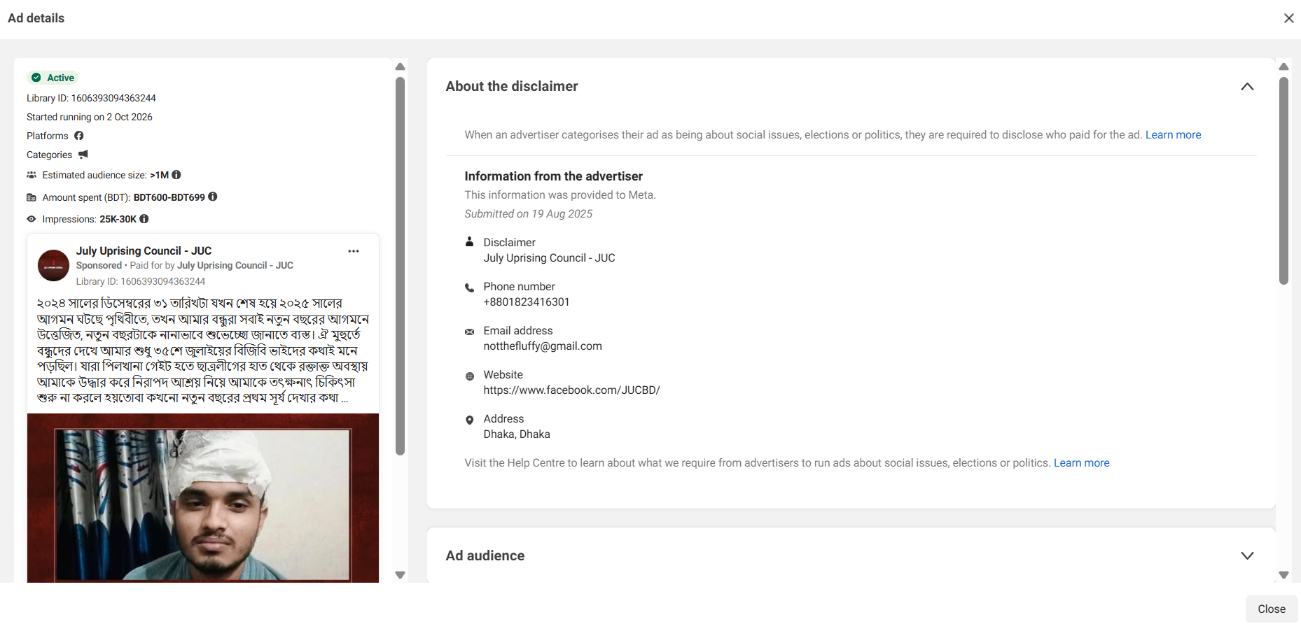
একই গল্প পোস্ট করা হয়েছে আরো তিনটি পেজে-
JRA-
শূন্যরেখা - https://www.facebook.com/shunnorekha/posts/pfbid033rkdLrcHwHFvq8BLhjV826eBXoqnaN1fLfLmEjhVzvXLLwz9kjWF7Lna4KRUPg2Fl
Bengal Soldier- https://www.facebook.com/AkibulHosenChayan/posts/pfbid0NTkWPfBw6DwA7WSkuc2MaMZGwKh8TMCVxPVdNpYt9fivTAZ8SJhcF8SQnyykbduKl

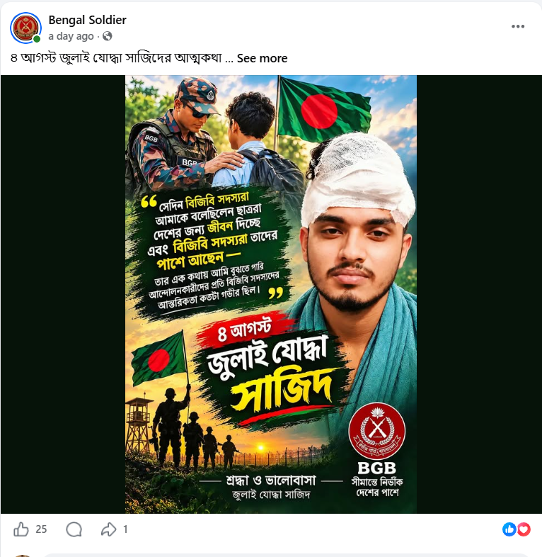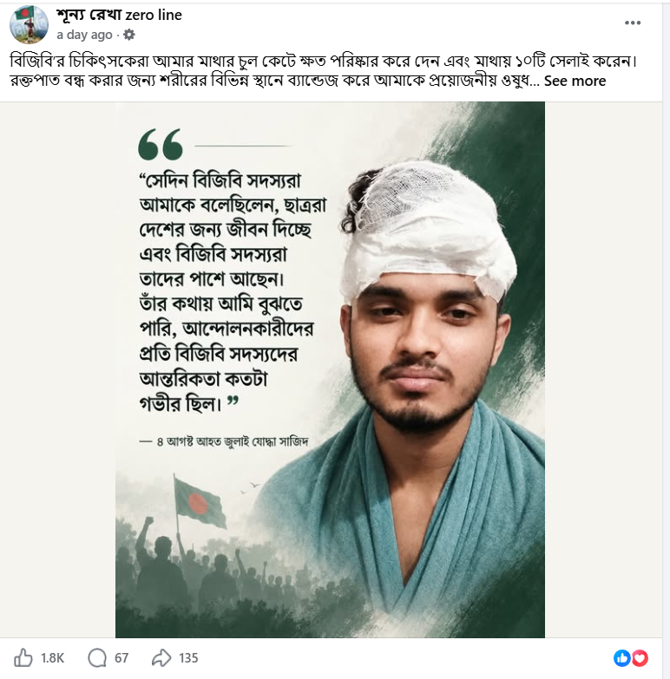

৫. পূর্বে সেনাবাহিনীকে একাধিক বিজ্ঞাপন দেওয়া পেজে প্রচার
বিজিবি ও বিজিবি মহাপরিচালককে নিয়ে স্বার্থান্বেষী প্রচার হচ্ছে এমন প্রচারণা চালানো হচ্ছে একটি পেজ থেকে। এই পেজ থেকে পূর্বে সেনাবাহিনী কিংবা নিরাপত্তা বাহিনীকে নিয়ে একাধিক বিজ্ঞাপন প্রচার হয়েছে।

পূর্বে পেজটি থেকে নিরাপত্তা বাহিনীকে নিয়ে পূর্বে ৬০ টি বিজ্ঞাপন প্রচার হয়েছে- https://www.facebook.com/ads/library/?active_status=all&ad_type=all&country=ALL&is_targeted_country=false&media_type=all&search_type=page&sort_data[mode]=total_impressions&sort_data[direction]=desc&view_all_page_id=631570113368664

৭. ক্রস কমেন্ট
১৭টি সম্পূর্ণ ইউনিক কমেন্ট পাওয়া গেছে, যেগুলো BGB Post এবং JRA Post—উভয় পোস্টেই হুবহু একইভাবে কপি-পেস্ট করা হয়েছে। এই ১৭টি কমেন্ট টেক্সট হুবহু BGB পোস্টে ৬৯টি কমেন্ট এবং JRA পোস্টে ৩৫টি কমেন্ট (মোট ১০৪টি কমেন্ট) করা হয়েছে।
ক্র. নং | কমেন্ট স্ক্রিপ্ট / টেক্সট | BGB Post-এ সংখ্যা | JRA Post-এ সংখ্যা | সর্বমোট
১ | সম্মানিত বিজিবি মহাপরিচালক মহোদয় একজন অত্যন্ত সৎ, দক্ষ, প্রজ্ঞাবান ও চৌকস অভিভাবক। স্যারের যোগ্য ও দূরদর্শী নেতৃত্বে আমার প্রিয় জন্মভূমির সীমান্ত সুরক্ষা নিশ্চিতের পাশাপাশি আজ বিজিবি বহির্বিশ্বে এবং দেশের জনগণের নিকট এক অনন্য উচ্চতায় আসীন। বিজিবি পরিবারের প্রতিটি সদস্য স্যারের ওপর অগাধ আস্থা ও বিশ্বাস রাখে। আল্লাহ তাআলা স্যারকে দীর্ঘায়ু ও সুস্থতা দান করুন, আমিন। | ২৯ | ৯ | ৩৮
২ | বিজিবির মহাপরিচালক হিসেবে একজন সৎ ও দক্ষ একজন মহাপরিচালক। | ১৮ | ১ | ১৯
৩ | বিজিবি একটি ঐতিহ্যবাহী ও সুশৃঙ্খল বাহিনী। কোনো অসত্য বা বিভ্রান্তিকর তথ্যের ভিত্তিতে এই বাহিনীর ঐতিহ্য ও অবদানকে ক্ষুণ্ন করা অনুচিত। গঠনমূলক সমালোচনার সুযোগ থাকলেও অপপ্রচার কখনোই গ্রহণযোগ্য হতে পারে না। | ৫ | ৪ | ৯
৪ | সম্মানিত ব্যক্তিদের অবদানকে অস্বীকার করে অসত্য ও ভিত্তিহীন তথ্য ছড়িয়ে তাঁদের হেয় করার অপচেষ্টা অত্যন্ত দুঃখজনক। বিজিবি ও দেশের প্রতি শ্রদ্ধাবোধ থেকেই এই ধরণের অপপ্রচারের বিরুদ্ধে আমাদের অবস্থান নেওয়া উচিত। | ২ | ৩ | ৫
৫ | বিজিবির অবদান ও ইতিহাসকে অপমান করার এই মিথ্যা প্রচারকে আমরা ধিক্কার জানাই। | ২ | ২ | ৪
৬ | কোনো অপপ্রচারে কান না দিয়ে দেশের সীমান্ত সুরক্ষায় বিজিবির দীর্ঘদিনের ত্যাগের ওপর আস্থা রাখুন।" | ১ | ৩ | ৪
৭ | বিজিবি সদস্যদের এবং ডিজির এমন সাহসী ও মানবিক সিদ্ধান্তকে বিনম্র সালাম!❣ | ১ | ২ | ৩
৯ | সত্যের জয় সুনিশ্চিত | ২ | ১ | ৩
১০ | বর্ডার গার্ড বাংলাদেশ (বিজিবি) একটি গৌরবময়, শৃঙ্খলাবদ্ধ ও ঐতিহ্যবাহী বাহিনী। এই বাহিনীর মহাপরিচালক হিসেবে দায়িত্ব পালন করা শুধু এক সম্মানিত পদই নয়, বরং দেশের সীমান্ত নিরাপত্তা রক্ষা এবং জাতীয় সার্বভৌমত্ব অক্ষুণ্ন রাখার ক্ষেত্রে এক অত্যন্ত গুরুত্বপূর্ণ ও দায়িত্বশীল দায়িত্ব। | ১ | ১ | ২
১১ | বিজিবির অর্জনকে কালিমালিপ্ত করার চেষ্টা বরদাশত করা হবে না। | ১ | ১ | ২
১২ | স্যার কে সালাম জানাই | ১ | ১ | ২
১৩ | শুভকামনা রইল স্যার ❤️ | ১ | ১ | ২
১৪ | বিজিবি আমাদের গর্ব। | ১ | ১ | ২
১৫ | আলহামদুলিল্লাহ | ১ | ১ | ২
মোট | ১৭টি ইউনিক কমেন্ট স্ক্রিপ্ট | ৬৯ | ৩৫ | ১০৪

